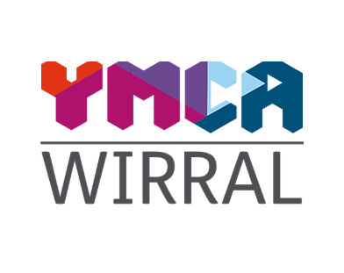
Job Description

Job Title: Activities Coordinator
Accountable to: CEO / Services Manager
Purpose of Job
The Activities Coordinator, is responsible for the organisation and delivery of a range of activities to improve the health and wellbeing of our residents.
The post holder will design and deliver a vibrant programme of activities that promote independence, community, and personal growth. You’ll work closely with residents, staff, volunteers and external partners to create inclusive experiences that build confidence, skills, and social connection.

Specific Duties

Key Responsibilities
- Plan and organise a programme of inclusive activities (e.g. arts, sports, life skills, social events, workshops etc) tailored to residents’ interests and needs
- Collaborate with external organisations who wish to deliver their activities and projects within our building
- Promote activities to service users and ensure good attendance levels at all sessions
- Build relationships with staff and recruit volunteers to enhance the activity programme
Delivery of Welfare and Support
- Ensure all activities comply with safeguarding, health and safety, and risk management policies
- Foster a welcoming and inclusive environment that encourages participation and builds community

Record Keeping & Report Writing

- Monitor attendance, gather feedback, and evaluate impact to continuously improve offerings
- Create and maintain accurate, up to date service-user records on the organisation’s databases
- Monitor a small budget

Partnership work
- Develop good working relationships with the various teams within the YMCA
- Attend and participate in regular team meetings
- Prepare for and attend supervision and appraisal sessions with the post holders line manager taking direction as appropriate

General
- Have a flexible and positive attitude to all team members
- Be committed to learning both as an individual and as part of a team
- Undertake own administrative services and report writing
- Uphold and develop Wirral YMCAW’s Equal Opportunities Policy of anti- discriminatory practices across all services
- Observe and ensure compliance with the YMCA Wirral’s Code of Conduct including professional boundaries and confidentiality
- Report and log all safeguarding incidents

Person Specification

Activities Coordinator
 |  | Essential / Desirable
Qualifications | Educated to A-level or equivalent vocational or professional training in arts, sports, health, psychology, social care or another related field  Educated to degree level | E  D
Experience | Experience working with vulnerable people or those who have complex needs  Experience handling safeguarding concerns  Personal or professional experience of homelessness, substance misuse or mental health  Experience in community engagement, youth work, support work, or activity coordination  Experience building partnerships with local organisations, volunteers, and service providers  Experience of data collection and collation  Experience of report writing or evaluations | E  D  D  D  D  D  E
Knowledge | Knowledge of the causes of homelessness, mental health and/or substance misuse  Familiarity with risk assessment and health & safety procedures in group settings | E  E
Skills & Abilities | Excellent organisation skills and the ability to manage multiple projects at once  IT skills in Microsoft Office applications  Excellent communication and interpersonal skills  Emotional intelligence  Ability to motivate and inspire participation across diverse groups  Ability to remain calm when dealing with challenging situations  Confident in facilitating group sessions and one-to-one interactions  Basic budgeting skills | E  E  E  E  E  E  E
Personal Attributes and Behaviours | Organised, creative and resourceful  Reliable with a strong work ethic  Committed to equal opportunities and anti-discriminatory practice  Highly empathetic, respectful and non-judgmental  Friendly personality, confident and outgoing  Reliable, flexible, and responsive to the needs of residents  Flexibility to work evenings and weekends on occasion | E  E  E  E  E  E  E

