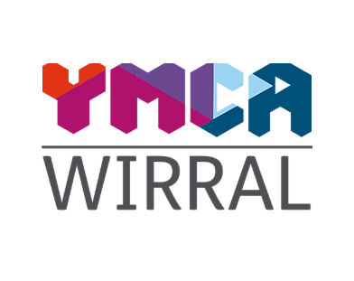
Job Description

Job Title: Night Services Officer
Accountable to: Night Services Manager
Purpose of Job
The Night Services Officers are responsible for overseeing care delivery across our sites, maintaining a safe and trauma-informed environment, and supporting some of the community’s most vulnerable people through crisis and transition.
The role ensures residents, staff, volunteers and visitors are safe and happy in all YMCAW environments during the late hours of the evening through to morning.
They will also be responsible for overseeing the delivery of a range of maintenance, security and domestic tasks during night shifts.

Specific Duties

Care of Residents

- Offer emotional support and practical help to hostel residents during late night and early hours of the morning
- Safeguard the health and wellbeing of all residents
- Respond to incidents and challenging situations with professionalism and calm
- Provide an excellent level of resident care
- Provide first aid assistance when needed
- Observe the YMCAs policy on Data Protection and Code of Confidentiality

Buildings Maintenance & Repair

- Work within relevant Health and Safety guidelines
- Oversee the completion of a range of low-level maintenance/DIY tasks as and when required
- Oversee the completion of a monthly and weekly programme of domestic tasks
Record Keeping & Report Writing

- Create and maintain accurate, up to date service-user records on the organisation’s databases
- Write shift reports and handover documents

Safety & Security of Building

- Ensure the recording of all visitors and residents leaving and entering the building
- Ensure the completion of all tasks related to fire safety and building security
- Oversee the completion of fire-rounds of the building during each shift noting any details on the duty report
- Oversee regular checks of the grounds to ensure the security of the premises
- Monitor surveillance equipment and respond to any issues requiring attention
General
- Attend regular formal supervision and appraisals
- Attend training and development opportunities
- Develop positive working relationships with YMCAW colleagues and the wider YMCA community, referring agencies, statutory services and other key stakeholders
- Work to agreed individual, team and organisational objectives and YMCAW performance targets
- Comply with all YMCAW policies and procedures
- Any other reasonable duties as required by the organisation

Person Specification

Night Services Manager
 |  | Essential / Desirable
Qualifications | Educated to A-level or equivalent vocational or professional training in mental health, psychology, social care, criminal justice, or related field  Educated to degree level | E  D
Experience | Experience working with vulnerable individuals  Experience handling safeguarding concerns  Experience of working in the not-for-profit sector  Experience working overnight | E  D  D  D
Knowledge | Knowledge of health, social care, housing or criminal justice systems  Knowledge of causes of homelessness, mental health and/or substance misuse  Familiarity with support services in Merseyside or surrounding areas  An understanding of aspects of security of buildings and accommodation | E  E  D  D
Skills & Abilities | IT skills in Microsoft Office applications  Excellent communication and interpersonal skills  Practical approach to problem-solving  Emotional intelligence  Ability to remain calm under pressure | E  E  E  E  E
Personal Attributes and Behaviours | Self-motivated  Reliable with a strong work ethic  Passionate about the aims and objectives of YMCAW  Committed to equal opportunities and anti-discriminatory practice  Prepared to work weekends and unsociable hours  Highly empathetic, respectful and non-judgmental | E  E  E  E  E  E

